**Screenshot of the HTML and CSS for the Resume web page**

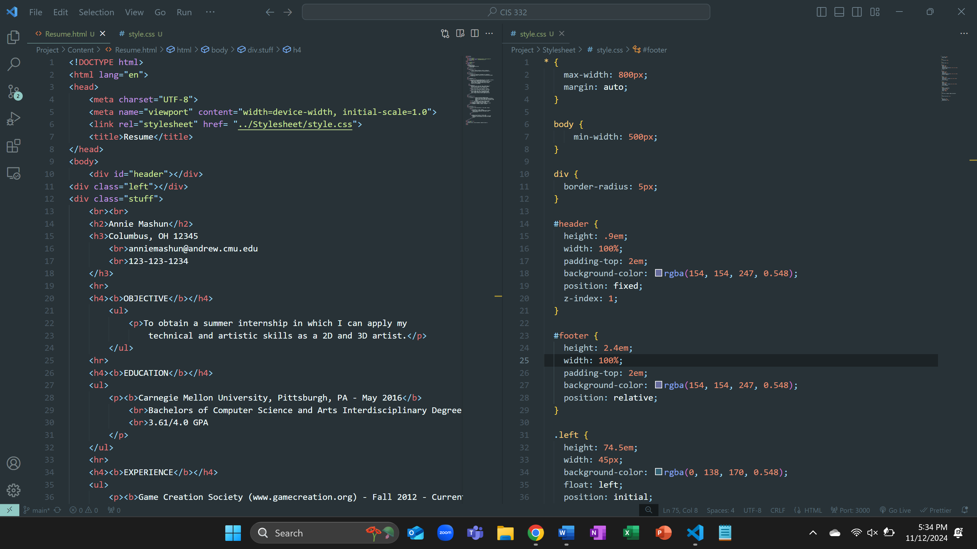

**Screenshot of the Resume web page**

